C4 model

-Rik Heerholtz

Contents

C1: context diagram 3

C2: Container diagram 4

C3: Component Diagram 5

C4: Classen Diagram 6

# C1: context diagram

# C2: Container diagram

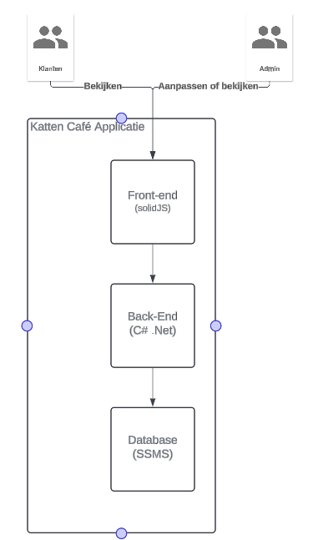

# C3: Component Diagram

# C4: Classen Diagram